Java BufferedWriter Class

Java BufferedWriter class is used to provide buffering for Writer instances.

It makes the performance fast.

It inherits Writer class.

The buffering characters are used for providing the efficient writing of single arrays, characters, and strings.

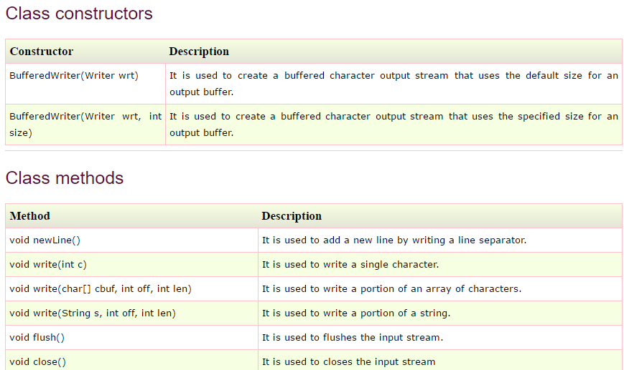

# 

# -Java BufferedReader Class->

# * Java BufferedReader class is used to read the text from a character-based input stream.

# * It can be used to read data line by line by readLine() method. It makes the performance fast. It inherits Reader class.

## **Java BufferedReader class declaration->**